Reactjs E-commerce Application - Final Project - 1

Pushed code to git dev branch

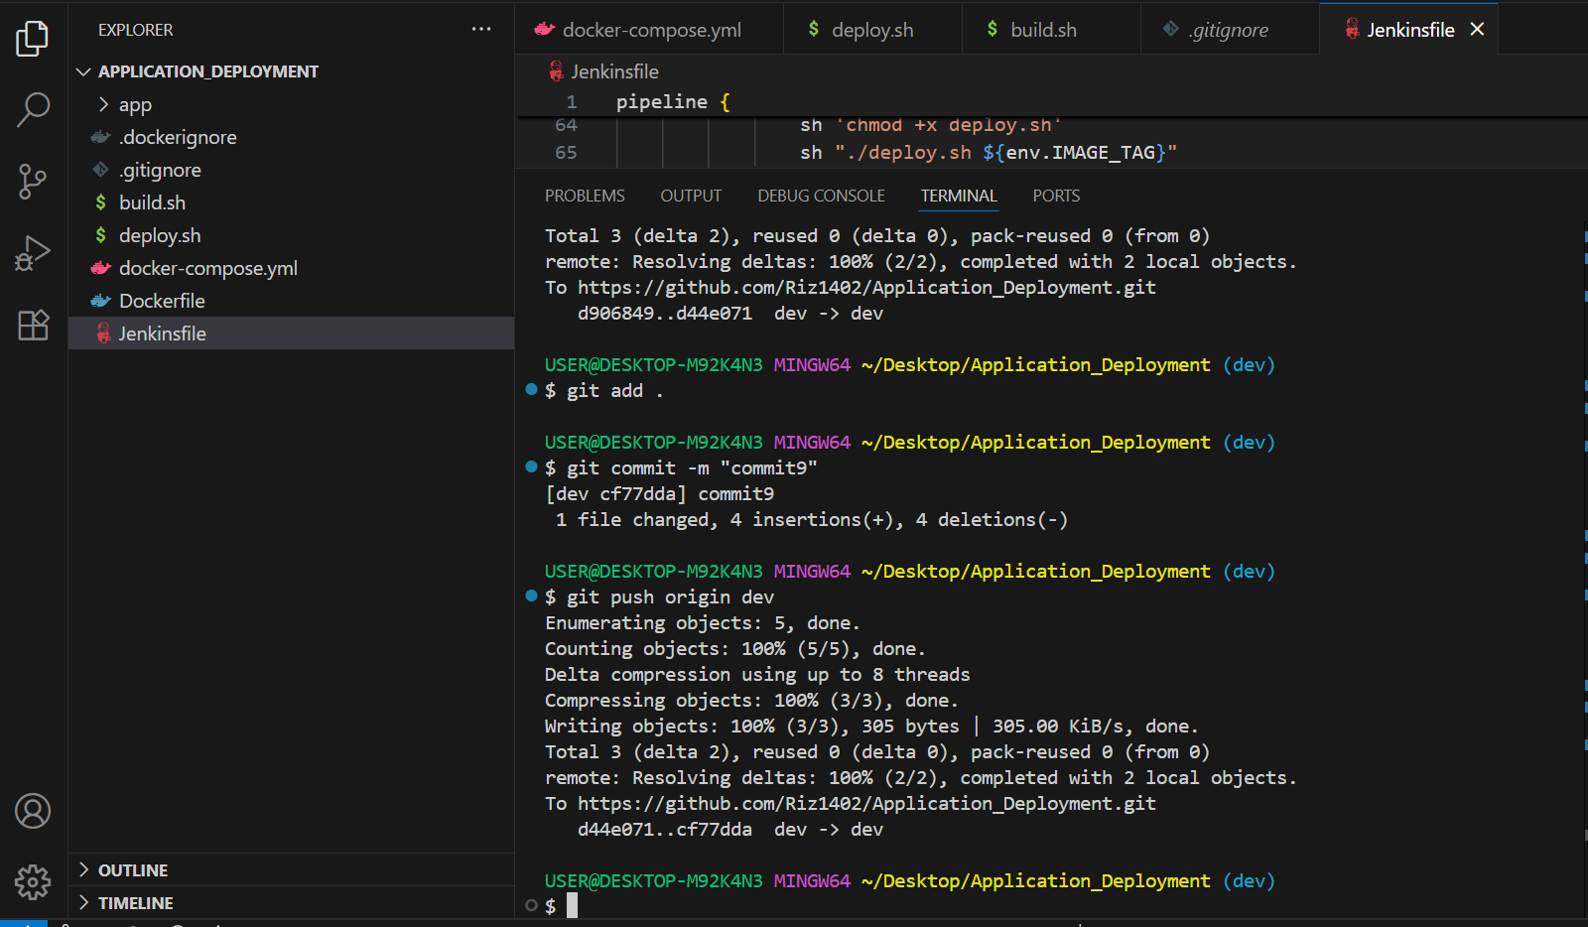

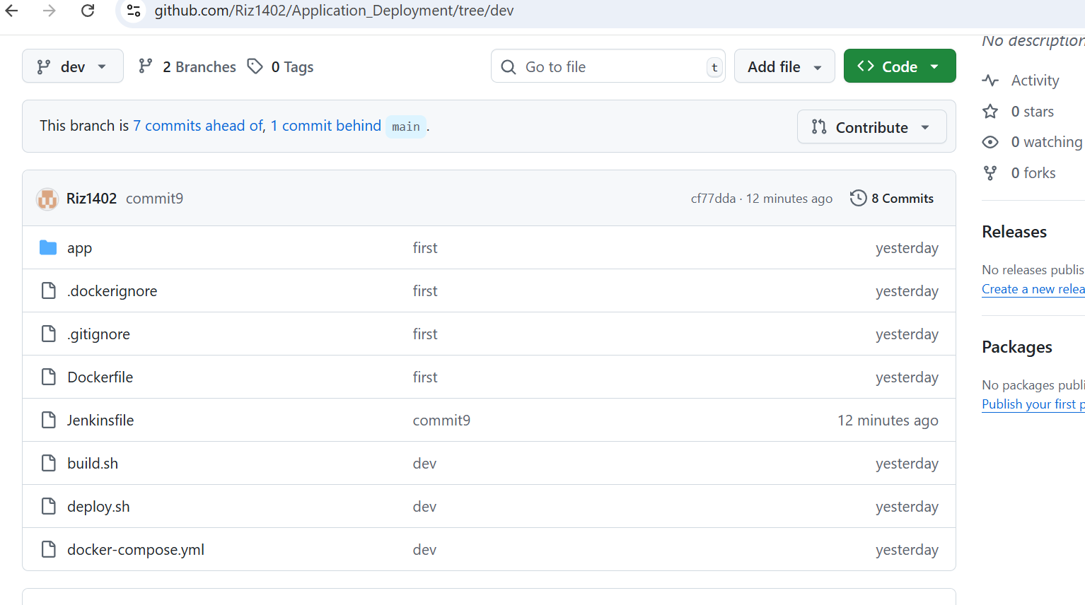

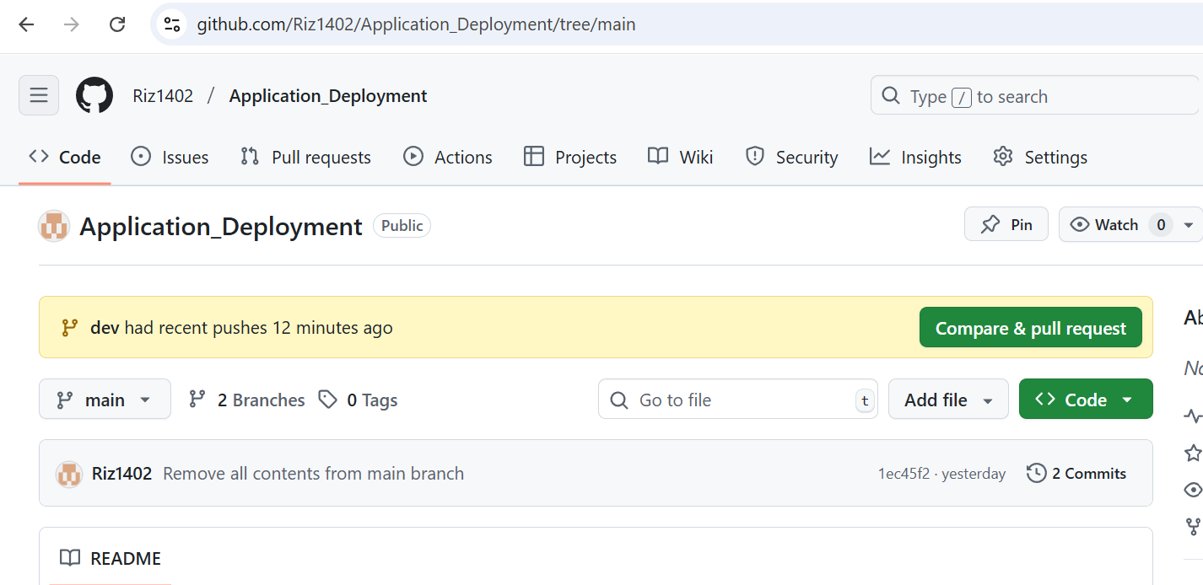

Successful Jenkins deployment using dev branch

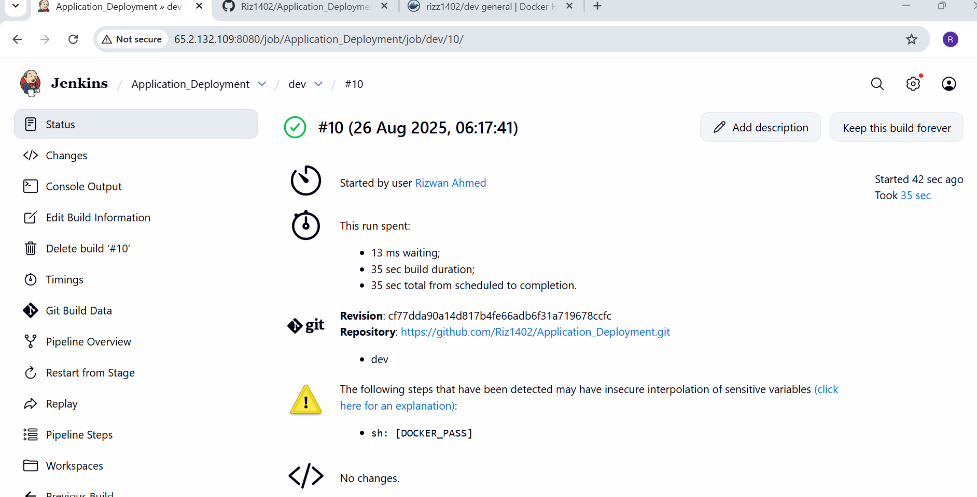

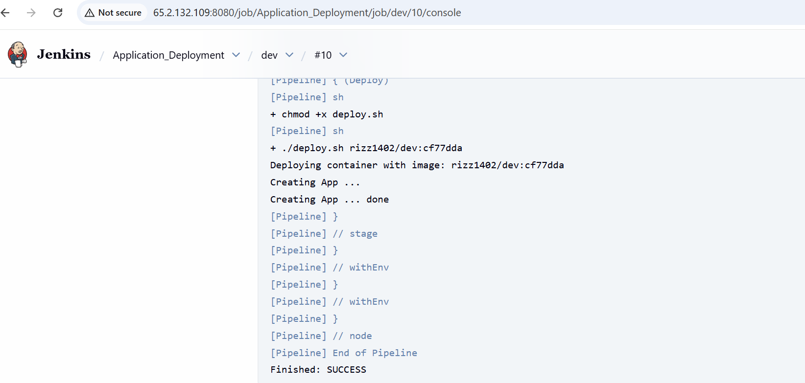

Image pushed to docker hub dev repo

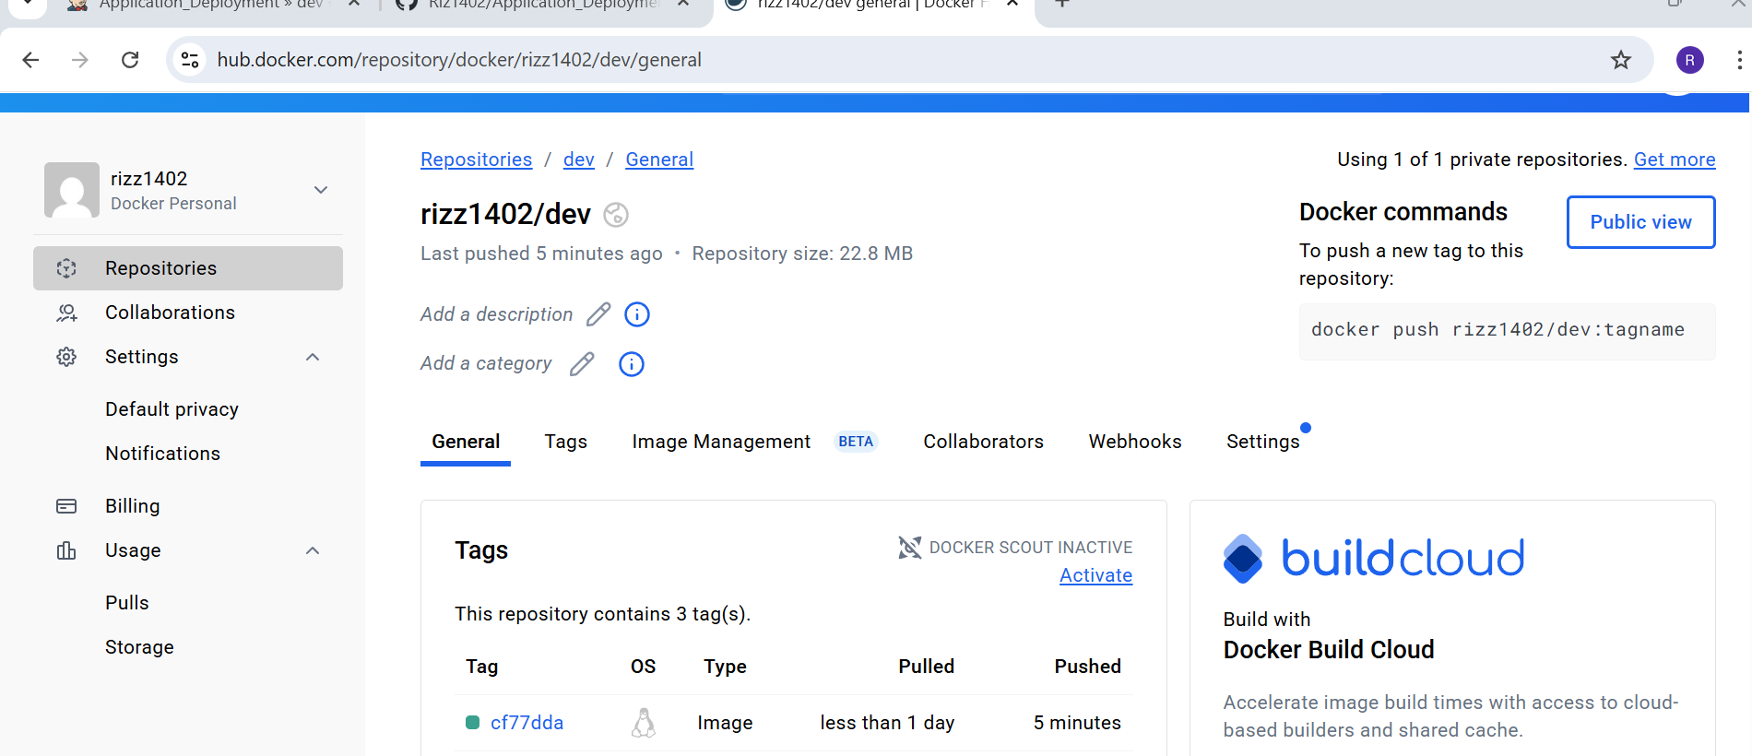

Docker images and container running in server

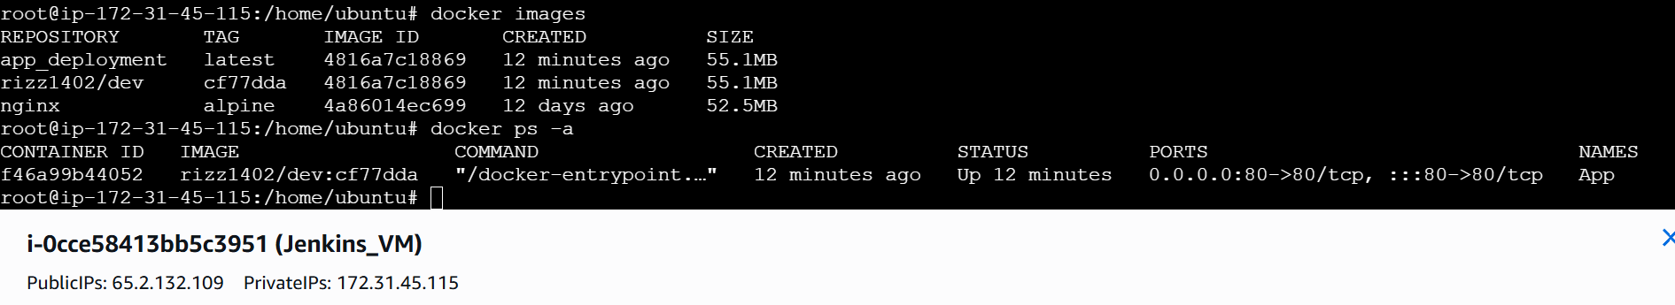



Application Screen

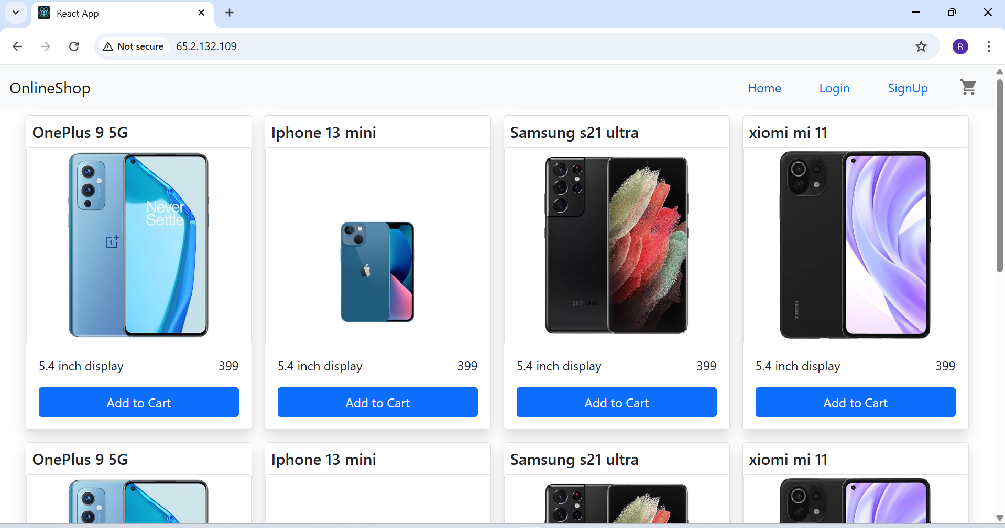

Created pull request to push code to main

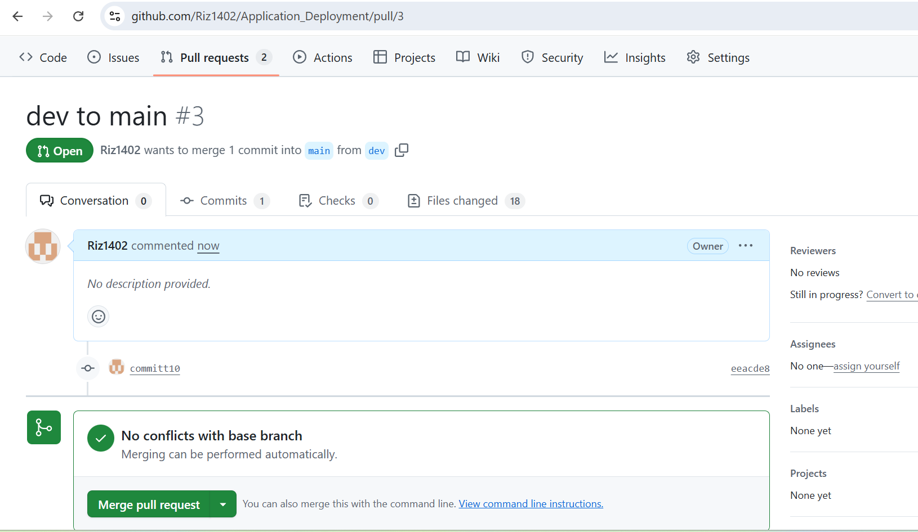

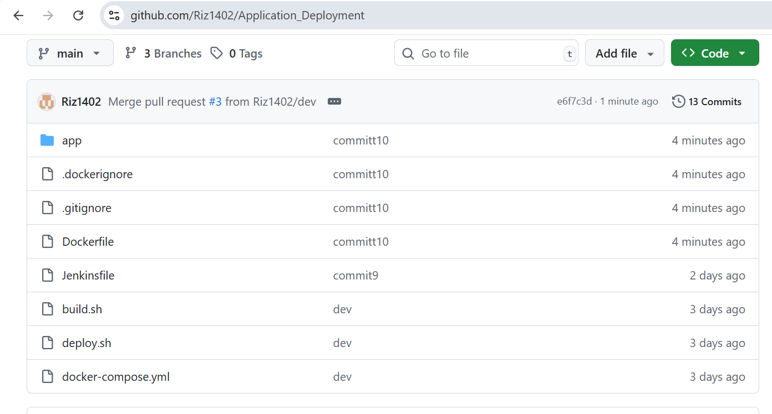

Main branch Jenkins job completed successfully

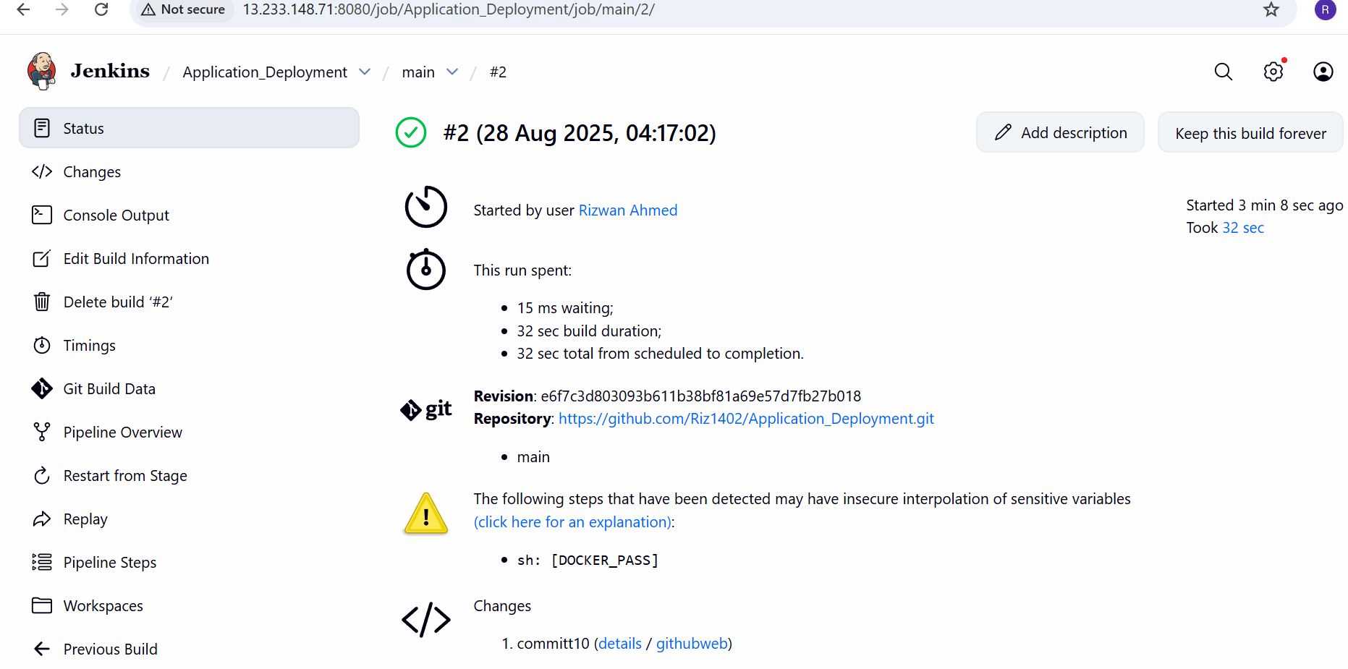

Pushed image to Prod Repo in docker hub

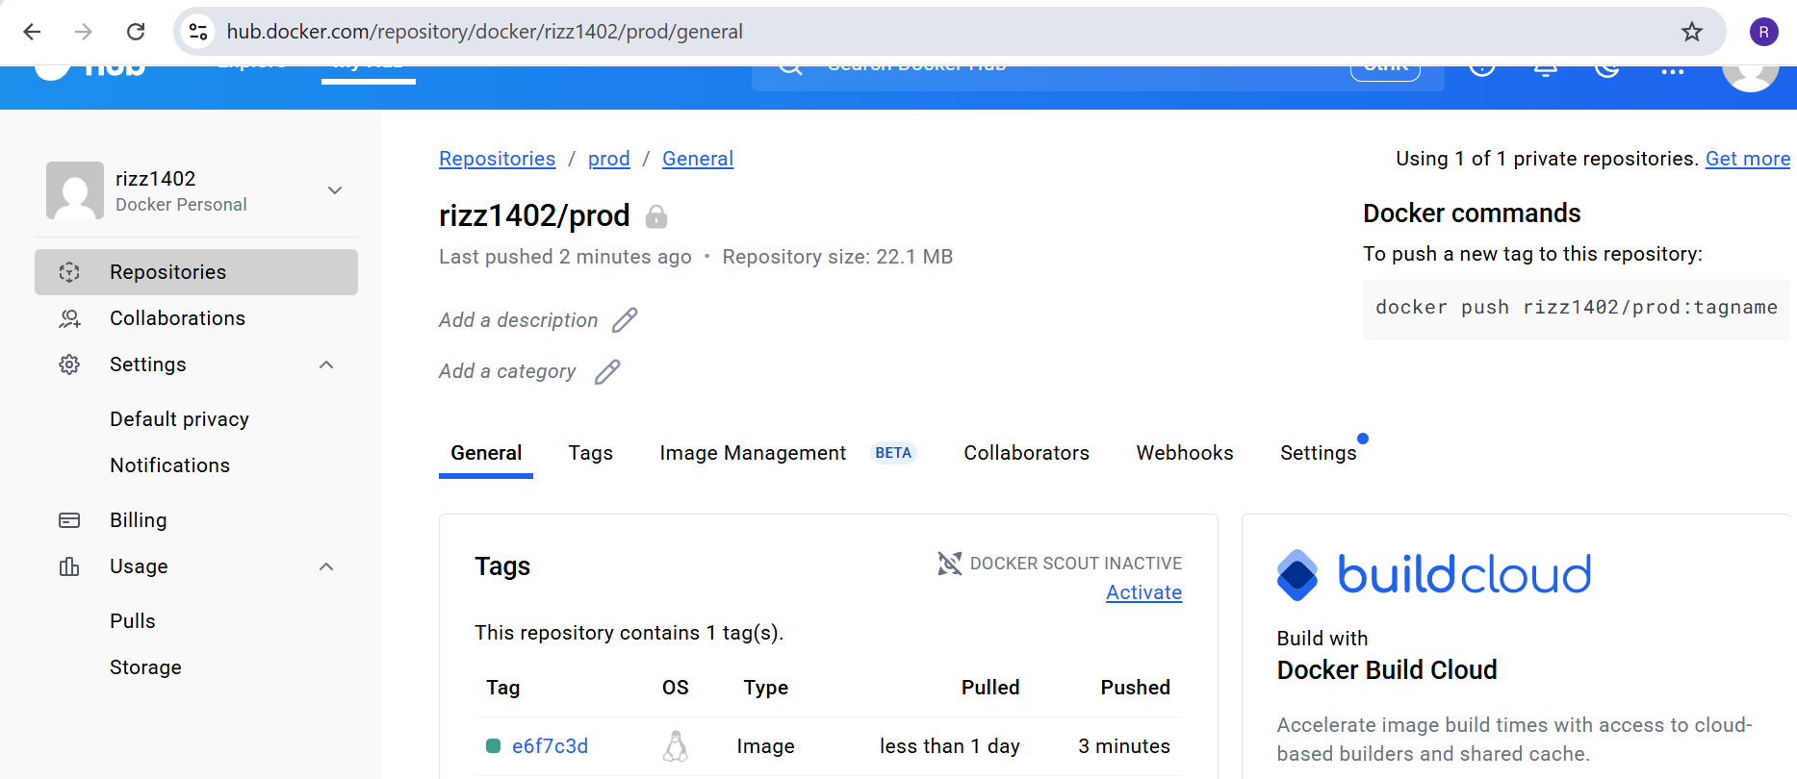

Docker images and containers

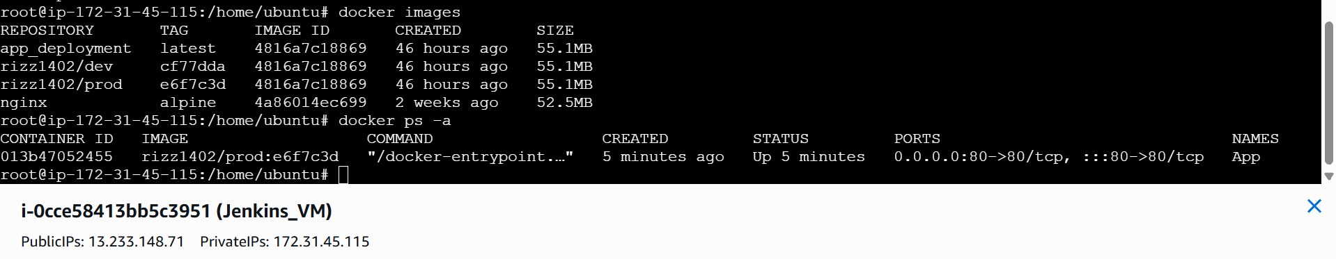

App screen for pod deployment

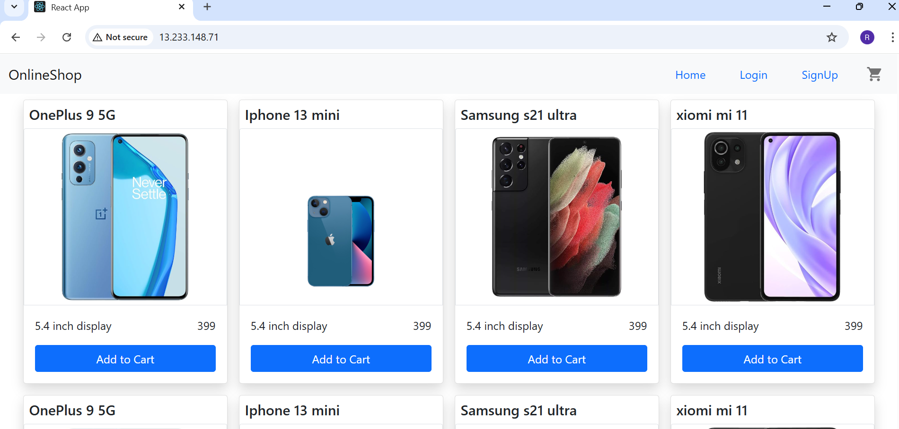

AWS Security Group configuration

1. Any one having IP address can access the application.

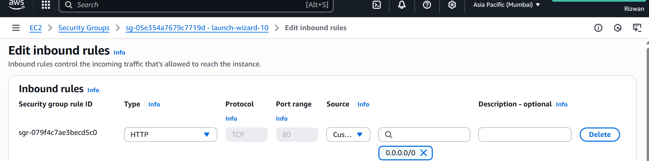

1. Login to server should be made only from my IP address.

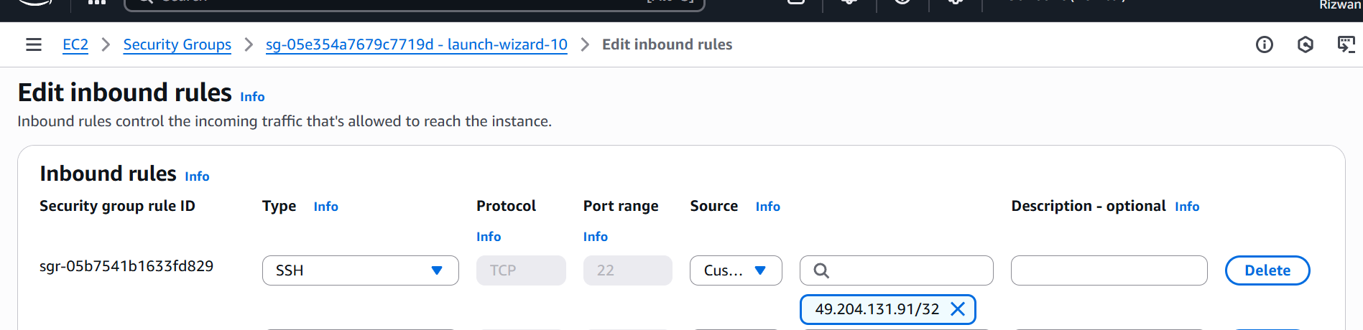

My IP

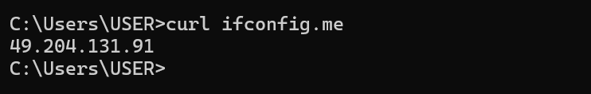

Monitoring setup

Brought up docker containers for Prometheus , Grafana and Alert manger

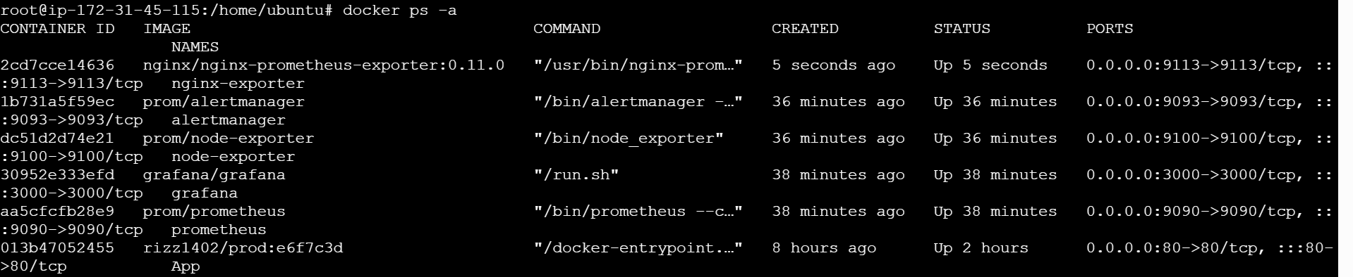

Created Prometheus.yml , alerts.rule.yml and alertmanager.yml files (files uploaded in git repo)

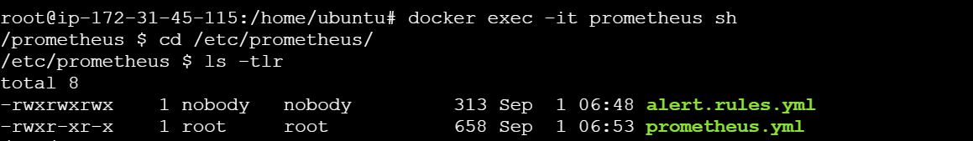

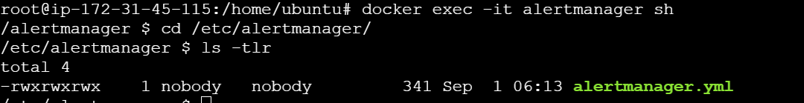

Monitoring

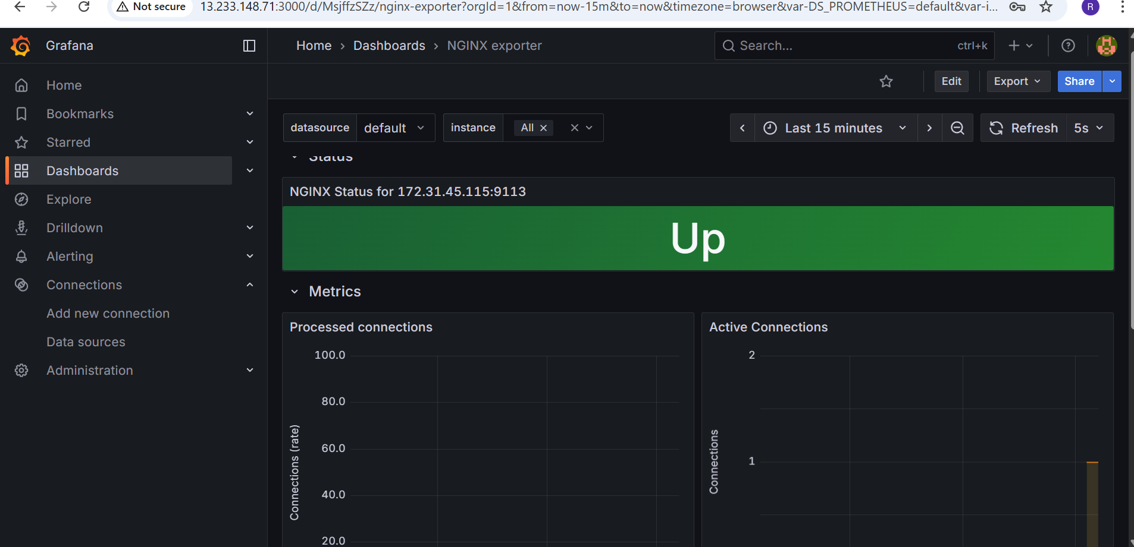

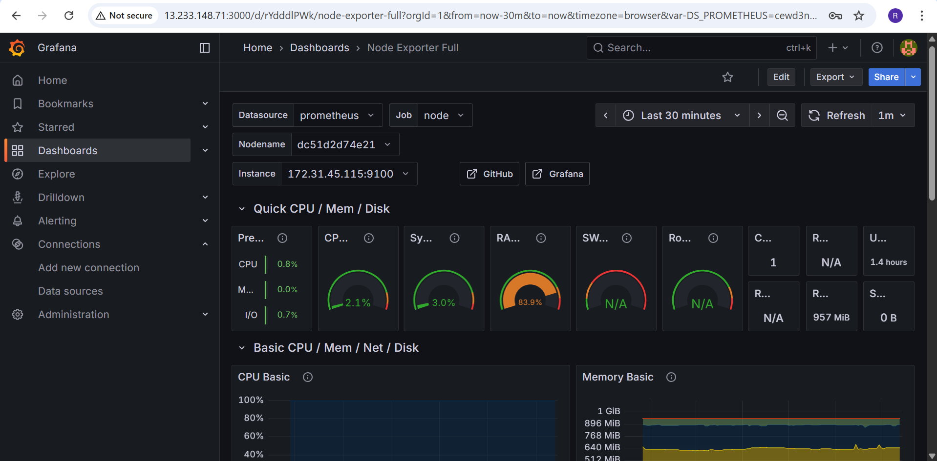

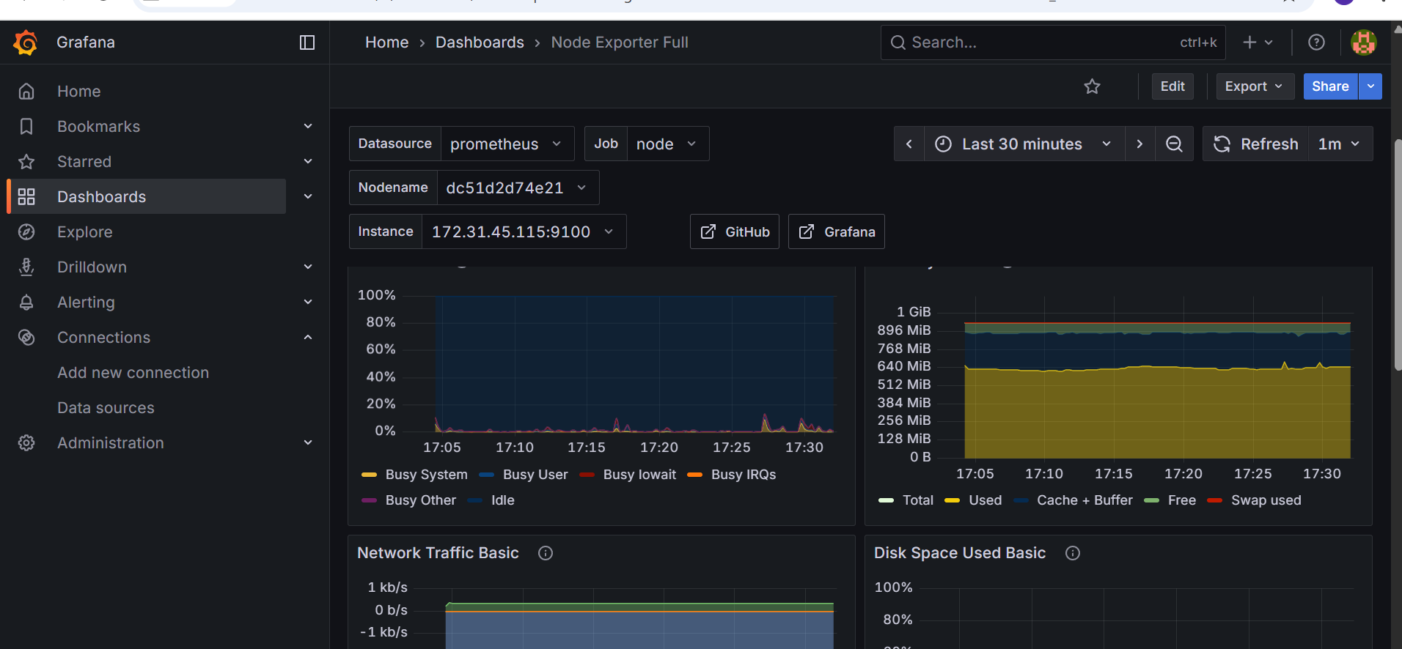

Stopped the App container

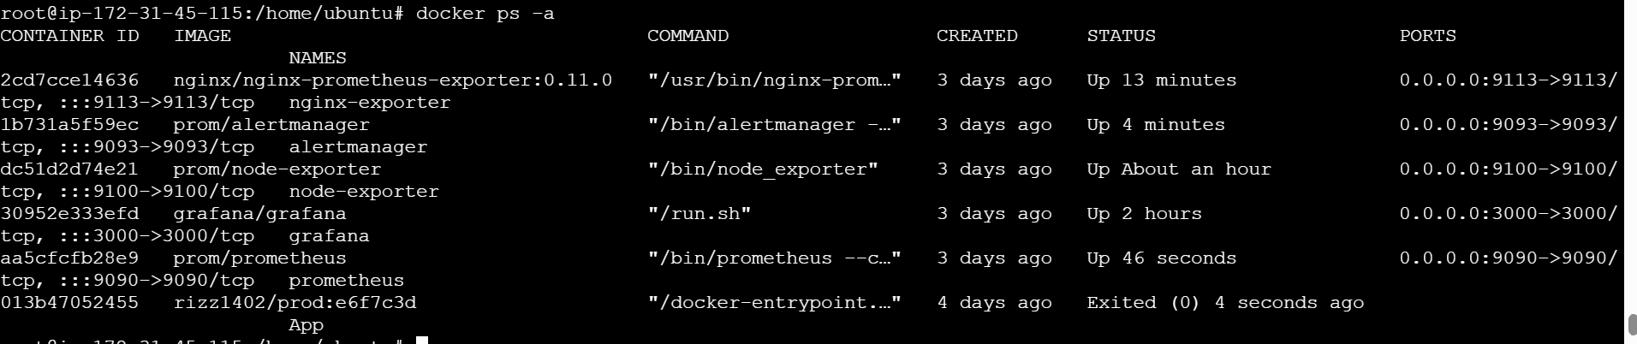

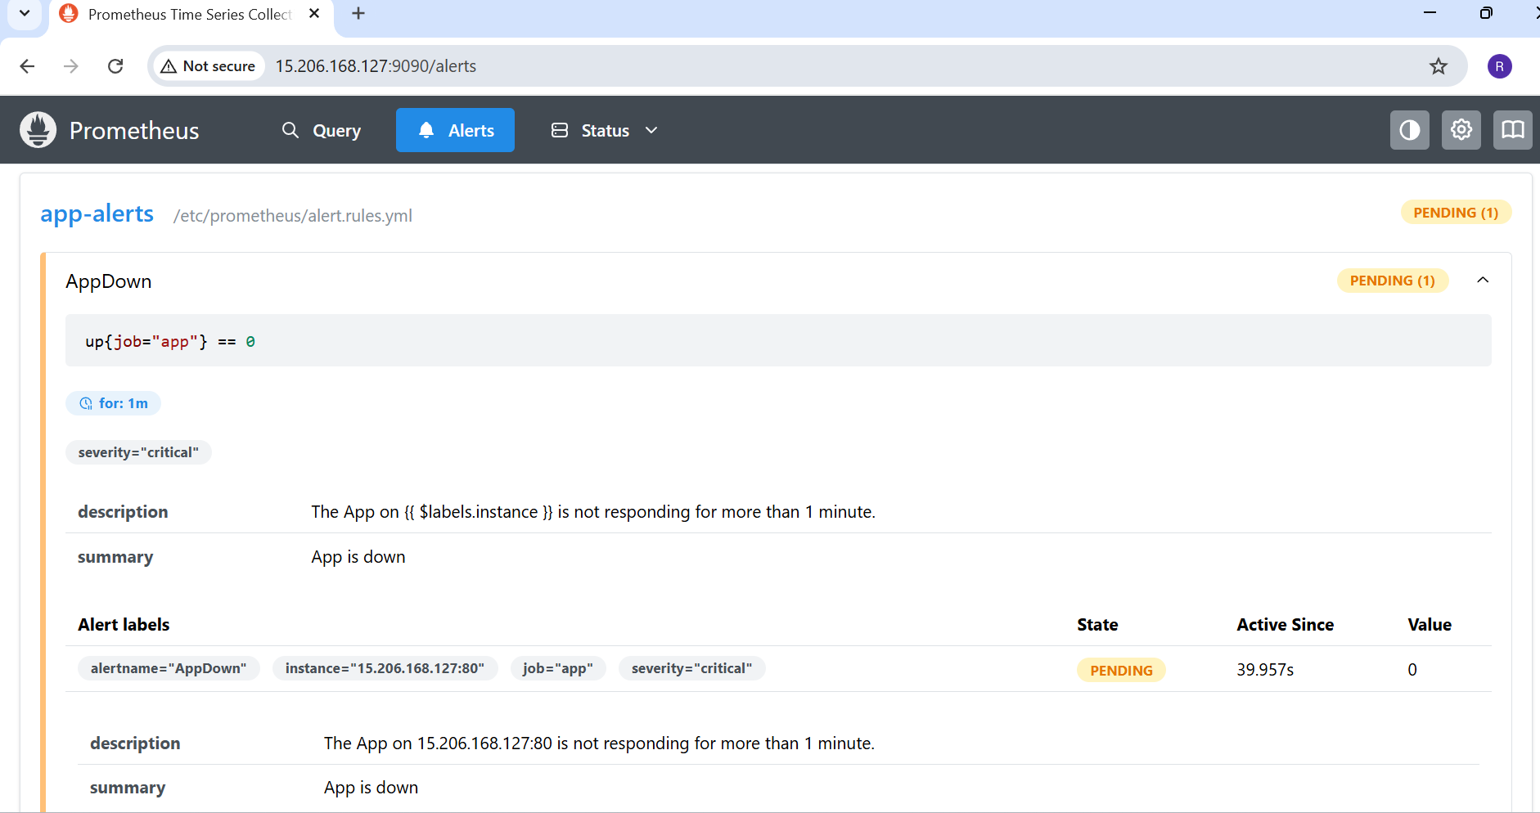

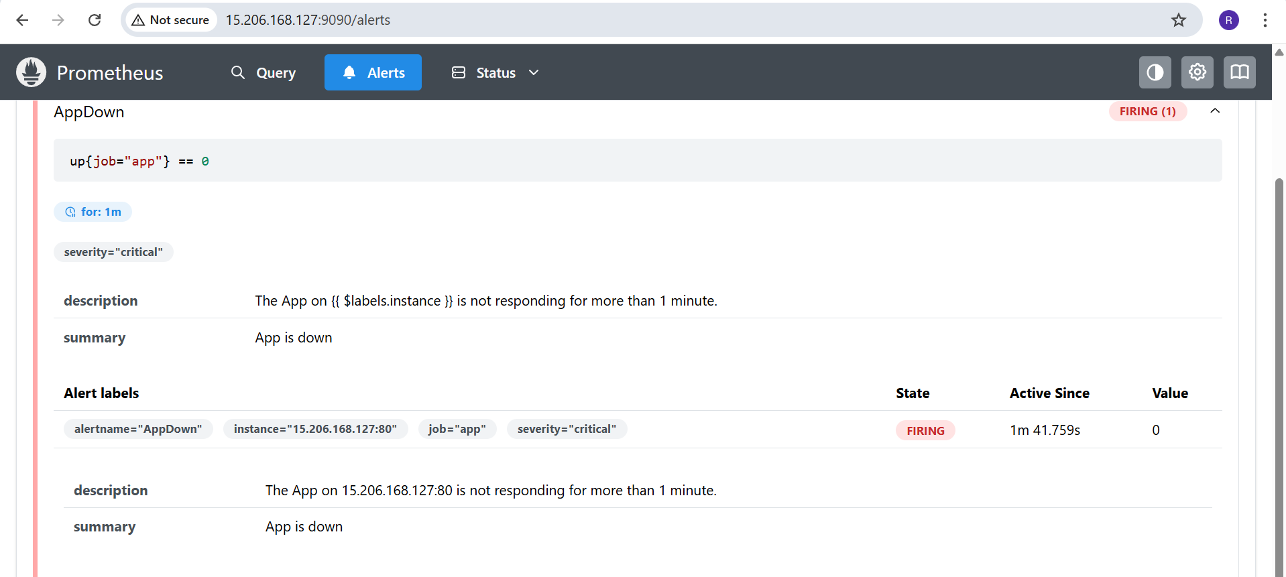

Email alert received

